Drying and Ignition of Precipitates
After filtration, a gravimetric precipitate is heated until its mass becomes constant. This removes solvent and other volatile species carried down with the precipitate. Some precipitates are ignited to decompose the solid and form a compound of known composition (weighing form).

The temperature required varies from precipitate to precipitate. The next figure shows mass loss as against temperature for several common analytical precipitates. Heating silver chloride, barium sulfate, and aluminum oxide, removes water and any volatile electrolytes. Moisture is completely removed from silver chloride at temperatures higher than 110ºC, but dehydration of aluminum oxide is not complete until a temperature greater than 1000°C is achieved. Aluminum oxide formed with urea can be completely dehydrated at about 650°C.

The thermal curve for calcium oxalate is considerably more complex. Below 135°C, unbound water is eliminated to give the monohydrate CaC₂O₄. H₂O. This compound is then converted to the anhydrous oxalate CaC₂O₄ at 225°C. The abrupt change in mass at about 450°C indicates the decomposition of calcium oxalate to calcium carbonate and carbon monoxide. The final step in the curve depicts the conversion of the carbonate to calcium oxide and carbon dioxide. As seen, the compound weighed in a gravimetric determination of calcium by oxalate is dependent on the ignition temperature.
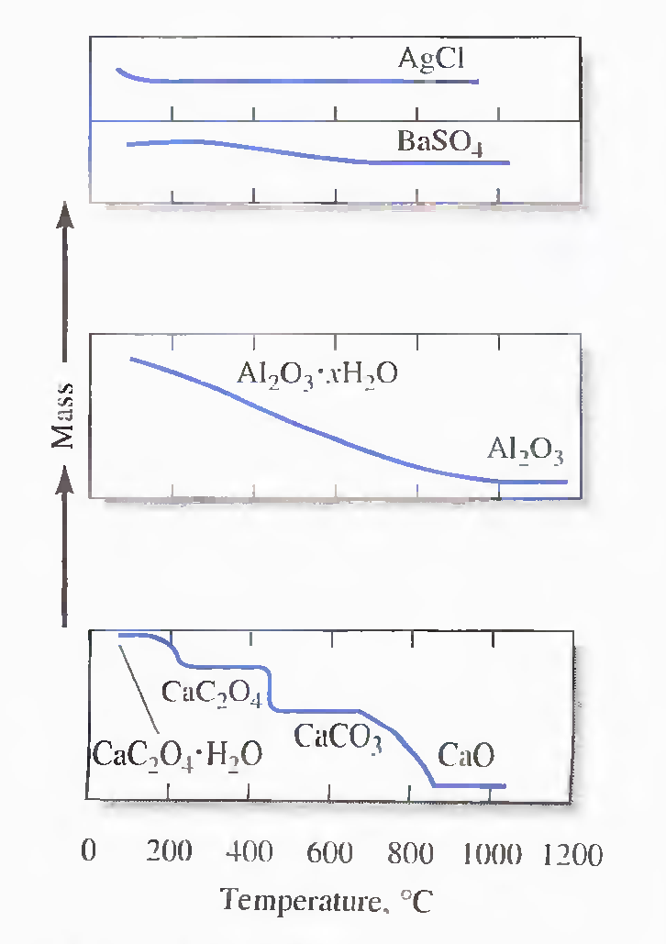

Calculating Results
The results of a gravimetric analysis are generally computed from the mass of sample and the mass of a product of known composition using the proper stoichiometry.

Example 1
The calcium in a 200.0-mL sample of a natural water was determined by precipitating the cation as CaC₂O₄ . The precipitate was filtered. washed, and ignited in a crucible with an empty mass of 26.6002 g. The mass of the crucible plus CaO (56.0n g/moI) was 26.7134 g. Calculate the concentration of Ca (40.078 g/mol) in water in units of grams per 100 mL of the water.
The mass of CaO is

26.7134 g - 26.6002 g = 0.1132 g

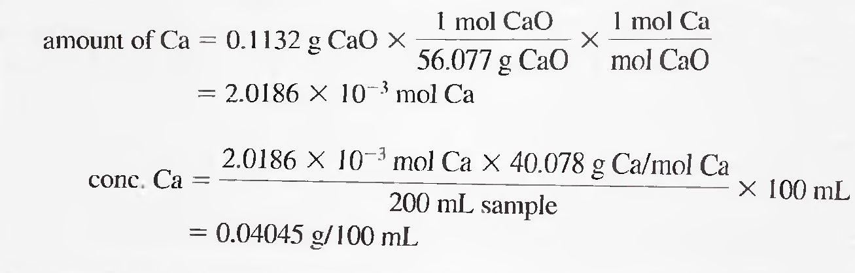

Example 2
An iron ore was analyzed by dissolving a 1.1324-g sample in concentrated HCl. The resulting solution was diluted with water, and the iron(III) was precipitated as the hydrous oxide Fe₂O₃. xH₂O by the addition of NH₃. After filtration and washing, the residue was ignited at a high temperature to give 0.5394 g of pure Fe₂O₃ (159.69 g/mol). Calculate (a) the % Fe (55.847 g/mol), and (b) the % Fe304 (231.54 g/mol) in the sample.
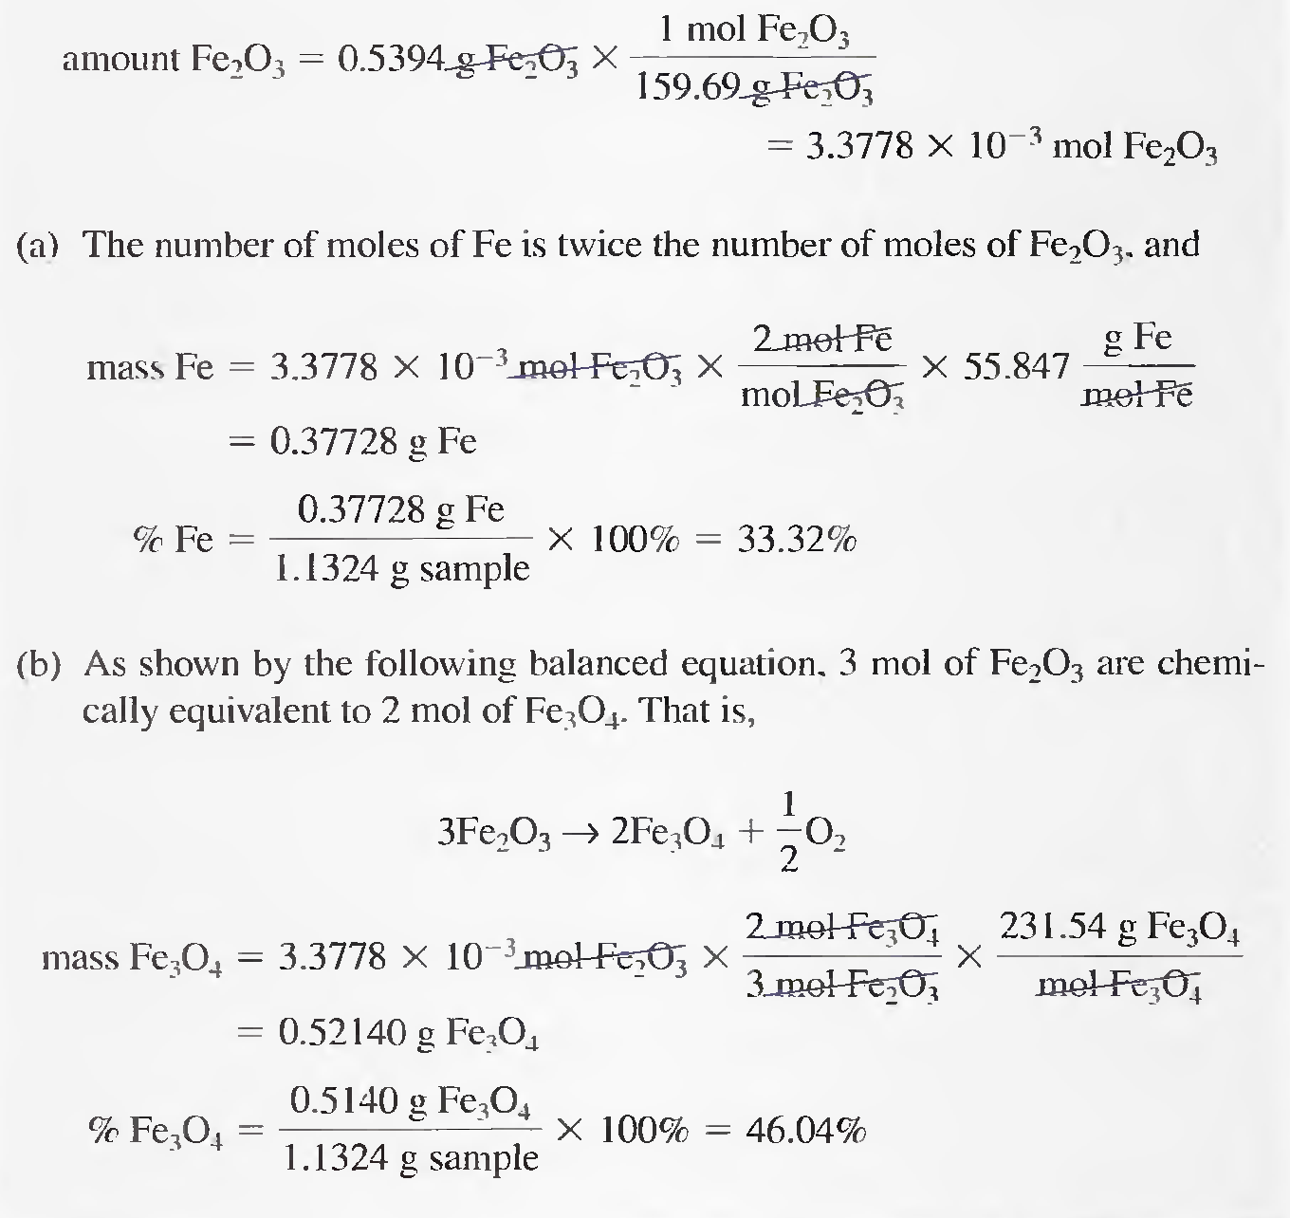

Example 3
A 0.2356-g sample containing only NaCI (58.44 g/mol) and BaCl₂ (208.23 g/mol) yielded 0.4637 g of dried AgCl (143.32 g/mol). Calculate the percent of each halogen compound in the sample.

Let x be the mass of NaCI in grams, and y be the mass of BaCl₂ in grams, then

x + y = 0.2356 g sample

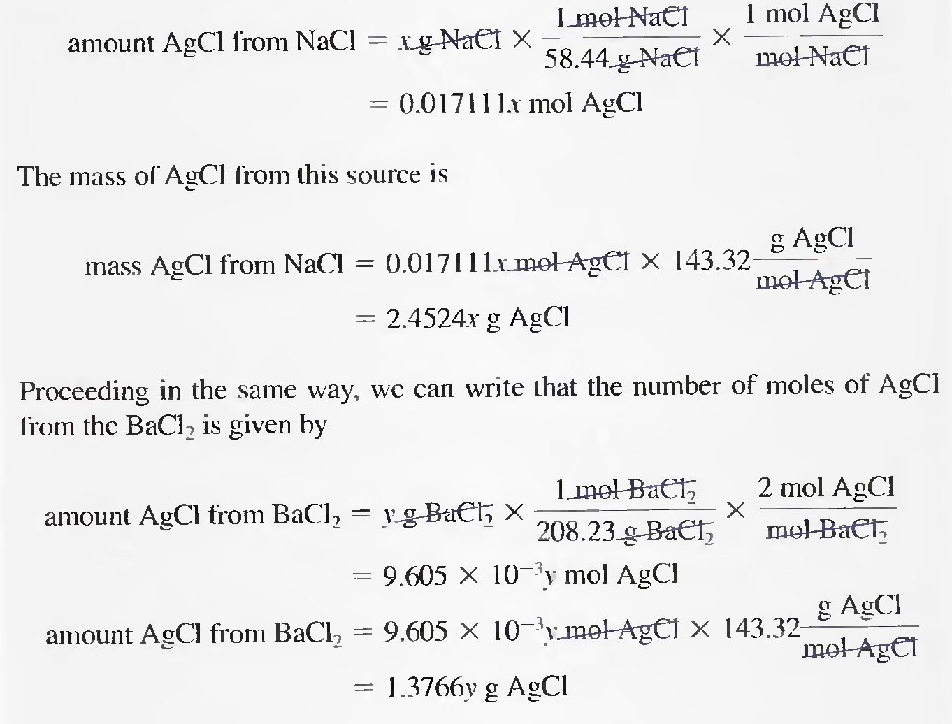
Because 0.4637 g of AgCl comes from the two compounds. we can write

2.4524x + 1.3766y = 0.4637

The first equation can be rewritten as

y = 0.2356 - x

Substituting into the previous equation gives

2.4524x + 1.3766 (0.2356 - x) = 0.4637

1.0758 x = 0.13942

x = mass NaCI = 0.12960 g NaCl

% NaCl = 0.12956 g NaCl /0.2356 g sample X 100% = 55.01 %

% BaCl₂ = 100.00% - 55.01 % = 44.99%

