The Effect of Other Complexing Agents on EDTA Titration Curves
Many cations form hydrous oxide precipitates at the pH required for their successful titration with EDTA. Here, an auxiliary complexing agent is needed to keep the cation in solution. For example, zinc(II) is ordinarily titrated in a medium that has fairly high concentrations of ammonia and ammonium chloride. These species buffer the solution to a pH that ensures complete reaction between cation and titrant; in addition. ammonia forms ammine complexes with zinc(II) and prevents formation of the sparingly soluble zinc hydroxide, particularly in the early stages of the titration.

Zn(NH₃)₄²⁺ + HY³⁻ → ZnY²⁻ + 3NH₃ + NH₄⁺

The following figure shows two theoretical curves for the titration of zinc(II) with EDTA at pH 9.00. Note that the presence of ammonia decreases the change in pZn near the equivalence point. For this reason, the concentration of auxiliary complexing reagents should always be the minimum required to prevent precipitation of the analyte. Note that the auxiliary complexing agent does not affect pZn beyond the equivalence point.
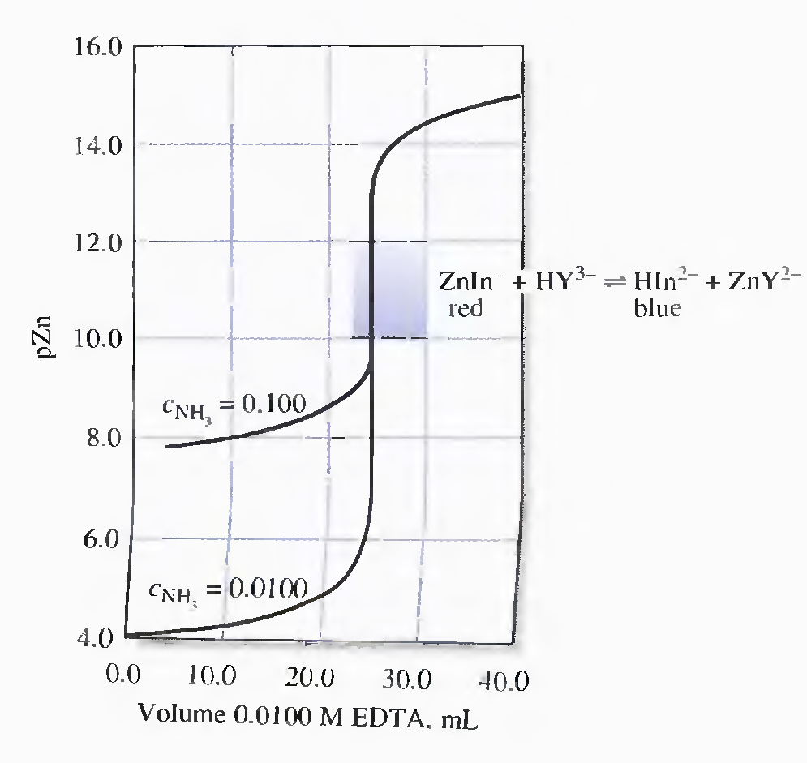

Indicators for EDTA Titrations
In general, indicators for metal ions in EDTA titrations, are organic dyes that form colored chelates with metal ions in a pM range that is characteristic of the particular cation and dye. The complexes are often intensely colored and are discernible to the eye at concentrations in the range of 10⁻⁶ to 10⁻⁷ M.
Eriochrome Black T is a typical metal ion indicator that is used in the titration of several common cations. The structural formula of Eriochrome Black T is shown below.
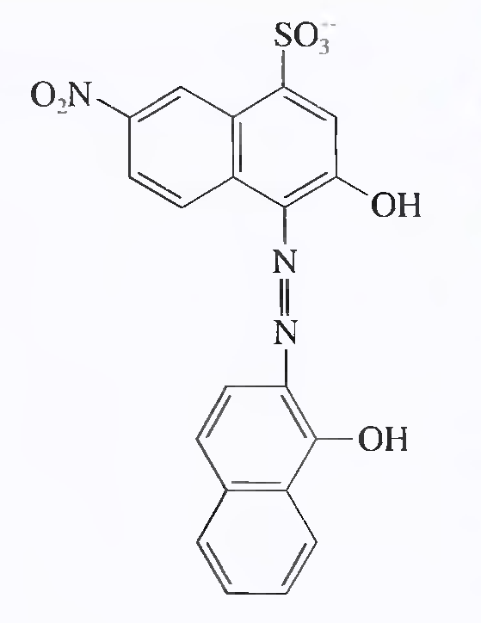

Its behavior as a weak acid is described by the equations:
H₂O + H₂In⁻_{(red)} ↔ HIn²⁻_{(blue)} + H₃O⁺, K₁ = 5 X 10⁻⁷
H₂O + HIn²⁻_{(blue)} ↔ In³⁻_{(orange)} + H₃O⁺, K₂ = 2.8 X 10⁻¹²

Eriochrome Black T (EBT), behaves as an acid/base indicator as well as a metal ion indicator. The metal complexes of EBT are generally red, as is H₂In⁻. Thus, for metal ion detection, it is necessary to adjust the pH to 7 or above so that the blue form of the species, HIn²⁻, predominates in the absence of a metal ion.
Until the equivalence point, the indicator complexes the excess metal ion so that the solution is red. With the first slight excess of EDTA, the solution turns blue.

Mln⁻_{(red)} + HY³⁻ ↔Hln²⁻_{(blue)} + MY²⁻

EBT forms red complexes with more than two dozen metal ions, but the formation constants of only a few are appropriate for end point detection.
Transition ranges for magnesium and calcium are indicated on the previously discussed titration curves. As can be seen, the indicator is ideal for the titration of magnesium but quite unsatisfactory for calcium. A limitation of EBT is that its solutions decompose slowly with standing.
Calmagite (shown below), is an indicator that is identical in behavior to EBT, do not suffer this disadvantage.
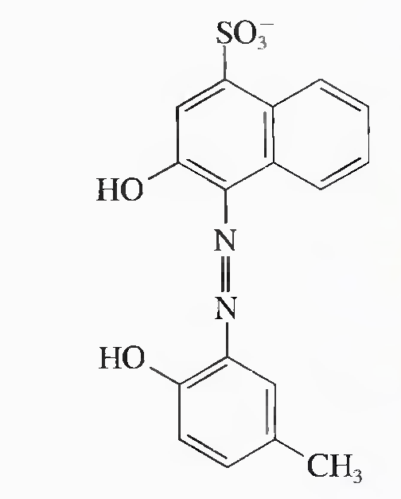

Titration Methods Employing EDTA
Direct Titration
Many of the metals in the periodic table can be determined by titration with standard EDTA solutions. Some methods are based on indicators that respond to the analyte itself, while others are based on an added metal ion. For example, indicators for calcium ion are generally less satisfactory than those for magnesium ion. Consequently, a small amount of magnesium chloride is often added to an EDTA solution that is to be used for the determination of calcium. In this case, EBT can be used in the titration. In the initial stages, magnesium ions are displaced from the EDTA complex by calcium ions and are free to combine with the EBT. thus imparting a red color to the solution. When all of the calcium ions have been complexed, however, the liberated magnesium ions again combine with the EDTA until the end point is observed. This procedure requires standardization of the EDTA solution against primary-standard calcium carbonate.

Back-titration Methods
Back-titration is used when cations lack a satisfactory indicator, or react slowly with EDTA. Back-titration is also useful for analyzing samples that contain anions that form sparingly soluble precipitates with the analyte under the analytical conditions. Here, the excess EDTA prevents precipitate formation.
A measured excess of standard EDTA solution is added to the analyte solution. After the reaction is judged complete, excess EDTA is back-titrated with a standard magnesium or zinc ion. It is necessary that magnesium or zinc ions form an EDTA complex that is less stable than the corresponding analyte complex.

Displacement Methods
Used when no indicator is available. Unmeasured excess of a solution containing the magnesium or zinc complex of EDTA is introduced into the analyte solution. If the analyte forms a more stable complex than that of magnesium or zinc, a displacement reaction occurs:
MgY²⁻ + M²⁺ ↔ MY²⁻ + Mg²⁺

where M²⁺ represents the analyte. The liberated Mg²⁺ (or Zn²⁺) is then titrated with a standard EDTA solution.

The Scope of EDTA Titrations
With the exception of the alkali metal ions, titrations with EDTA have been applied to the determination of every metal cation. Thus, the reagent might appear at first glance to be totally lacking in selectivity. In fact, however, considerable control over interferences can be realized by pH regulation. For example, trivalent cations can usually be titrated without interference from divalent specie by maintaining the solution at a pH of about 1. At this pH, the less stable divalent chelates do not form to any significant extent, but the trivalent ions are quantitatively complexed.
Similarly, ions such as cadmium and zinc, which form more stable EDTA chelates than does magnesium, can be determined in the presence of the latter ion by buffering the mixture to a pH of 7 before titration. EBT serves as an indicator for the cadmium or zinc end points without interference from magnesium because the indicator chelate with magnesium is not formed at this pH.

Finally, interference from a particular cation can sometimes be eliminated by adding a suitable masking agent, an auxiliary ligand that preferentially forms highly stable complexes with the potential interfering ion. Thus. cyanide ion is often employed as a masking agent to permit the titration of magnesium and calcium ions in the presence of ions such as cadmium, cobalt, copper, nickel, zinc, and palladium.

The Determination of Water Hardness
Hardness is expressed in terms of the concentration of calcium carbonate that is equivalent to the total concentration of all the multivalent cations in the sample.

Water hardness is ordinarily determined by an EDTA titration after the sample has been buffered to pH 10. Magnesium, which forms the least stable EDTA complex of all of the common multivalent cations in typical water samples, is not titrated until enough reagent has been added to complex all of the other cations in the sample. Therefore. a magnesium ion indicator, such as Calmagite or EBT, can serve as indicator in water hardness titrations. Often, a small concentration of the magnesium-EDTA chelate is incorporated into the buffer or the titrant to ensure sufficient magnesium ions for satisfactory indicator action.

