Determination of Organic Functional Groups
Carboxylic and Sulfonic Acid Groups
Most carboxylic acids have dissociation constants that range between 10⁻⁴ and 10⁻⁶, and thus these compounds are readily titrated. An indicator with a basic range, such as phenolphthalein, is required.
Many carboxylic acids are not sufficiently soluble in water to permit direct titration in this medium. Where this problem exists, the acid can be dissolved in ethanol and titrated with aqueous base. Alternatively. the acid can be dissolved in an excess of standard base followed by back-titration with standard acid.
Sulfonic acids are generally strong acids and readily dissolve in water. Their titration with a base is therefore straightforward.

Amine Groups
Aliphatic amines generally have base dissociation constants on the order of 10⁻⁵ and can thus be titrated directly with a solution of a strong acid. In contrast, aromatic amines such as aniline and its derivatives are usually too weak for titration in aqueous medium (K_{b} = 10⁻¹⁰). The same is true for cyclic amines with aromatic character, such as pyridine and its derivatives. Many saturated cyclic amines, such as piperidine, tend to resemble aliphatic amines in their acid/base behavior and thus can be titrated in aqueous media.
Many amines that are too weak to be titrated as bases in water are readily titrated in nonaqueous solvents, such as anhydrous acetic acid, which enhance their basicity.

Ester Groups
Esters are commonly determined by saponification with a measured quantity of standard base:

R1COOR₂ + OH- → R1COO⁻ + HOR₂

The excess base is then titrated with standard acid.

Hydroxyl Groups
Hydroxyl groups in organic compounds can be determined by esterification with various carboxylic acid anhydrides or chlorides; the two most common reagents are acetic anhydride and phthalic anhydride. With acetic anhydride, the reaction is

(CH3CO)₂O + ROH → CH₃COOR + CH₃COOH

The acetylation is ordinarily carried out by mixing the sample with a carefully
measured volume of acetic anhydride in pyridine. After heating, water is added to
hydrolyze the unreacted anhydride:

(CH3CO)₂O + H₂O → 2CH₃COOH

The acetic acid is then titrated with a standard solution of alcoholic sodium or potassium hydroxide. A blank is carried through the analysis to establish the original amount of anhydride.

Carbonyl Croups
Many aldehydes and ketones can be determined with a solution of hydroxylamine hydrochloride. The reaction, which produces an oxime, is

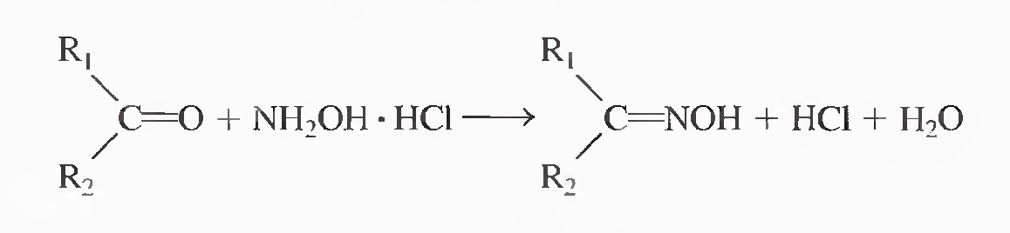

where R₂ may be an atom of hydrogen. The liberated hydrochloric acid is titrated with base.

Determination of Salts
The total salt content of a solution can be accurately determined by an acid/base titration. The salt is converted to an equivalent amount of an acid or a base by passage through a column packed with an ion-exchange resin.

Chapter 10

Complexation Reactions and Titrations

Objectives
In this chapter, we will have a look at the nature of complexes and their uses. Complexation of metal ions with certain ligands, such as aminocarboxylic acids will be investigated as a basis for the determination of these ions. Titration curves for EDTA titrations, indicators as well as some important applications will be studied.
The Formation of Complexes
Most metal ions react with electron-pair donors (ligands) to form coordination compounds or complexes. The ligand, must have at least one pair of unshared electrons available for bond formation.
The number of covalent bonds that a cation tends to form with electron donors is its coordination number. Typical values for coordination numbers are 2, 4, and 6. The species formed as a result of coordination can be electrically positive, neutral, or negative.
Ligands are classified according to the number of donor groups available. A ligand with a single donor group, such as ammonia, is called unidentate (single-toothed), whereas one that has two groups available for covalent bonding, is called bidentate. Tridentate, tetradentate, pentadentate, and hexadentate chelating agents are also known.
A chelate is produced when a metal ion coordinates with two or more donor groups of a single ligand to form a five- or six-member heterocyclic ring. The copper complex of glycine is an example.
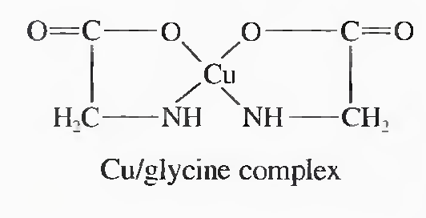
Aminocarboxylic Acid Titrations
Tertiary amines that contain carboxylic acid groups form remarkably stable chelates with many metal ions.

Ethylenediaminetetraacetic Acid (EDTA)
EDTA is the most widely used complexometric titrant. It has the structural formula

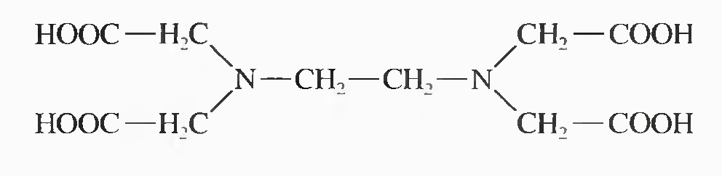
EDTA molecule has six potential sites (hexadentate) for bonding a metal ion; four carboxyl groups and the two amino groups.

Acidic Properties of EDTA
The dissociation constants for the acidic groups in EDTA are K₁ = 1.02 X 10⁻², K₂ = 2.14 X 10⁻³, K₃ = 6.92 X 10⁻⁷, and K₄ = 5.50 X 10⁻¹¹.

The various EDTA species are often abbreviated H₄Y, H₃Y⁻, H₂Y²⁻, HY³⁻, and Y⁴⁻. The next figure illustrates how the relative amounts of these five species vary as a function of pH. Note that the species H₂Y²⁻ predominates in moderately acidic medium (pH 3 to 6).

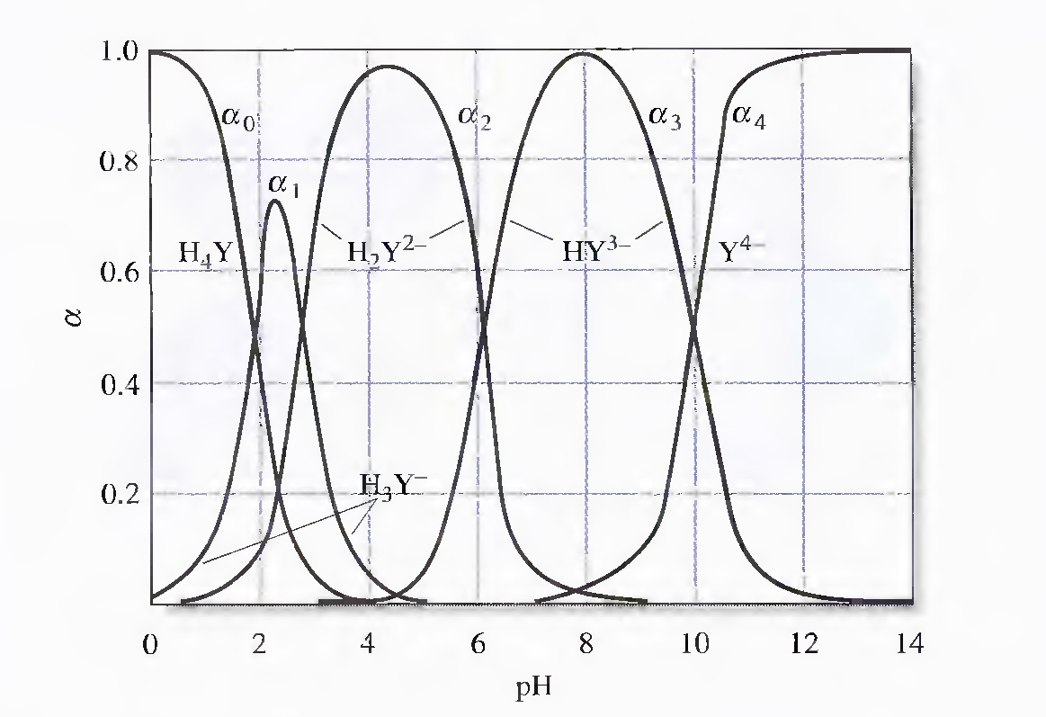

Reagents for EDTA Titrations
The free acid H₄Y and the dihydrate of the sodium salt, Na₂H₂Y. 2H₂O, are commercially available in reagent quality.

Complexes of EDTA and Metal Ions
Solutions of EDTA are particularly valuable as titrants because the reagent combines with metal ions in a 1 : 1 ratio regardless of the charge of the cation, e.g.,

Ag⁺ + Y⁴⁻ → AgY³⁻
Al³⁺ + Y⁴⁻ → AlY⁻

EDTA forms chelates with all cations (except alkali metals), most of these chelates are sufficiently stable for titrations. This great stability results from the several complexing sites within the molecule that give a cage-like structure, in which the cation is effectively isolated from solvent molecules. One of the common structures for metal/EDTA complexes is shown in the following figure.
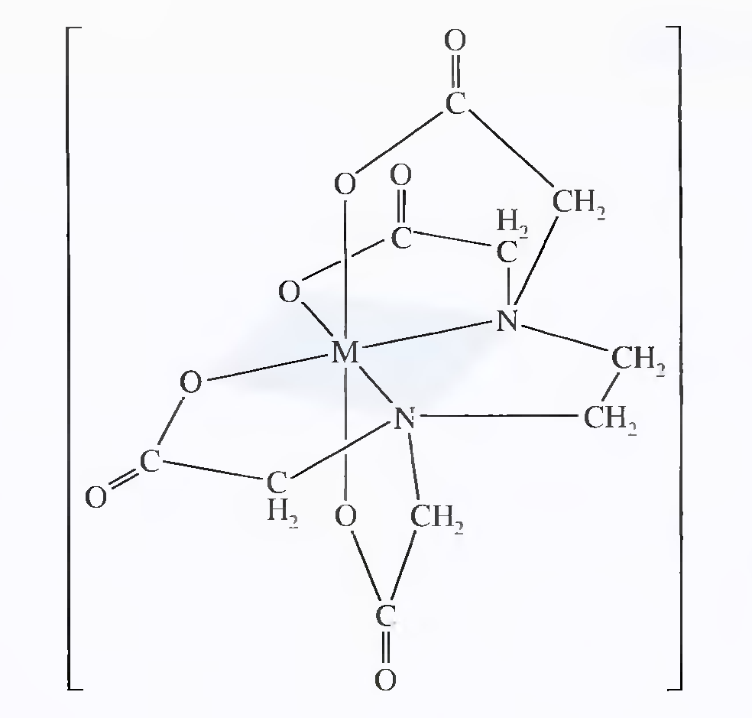

Formation constants K_{MY} for common EDTA complexes are shown below. The constant refers to the equilibrium involving the fully unprotonated species Y⁴⁻ with the metal ion:
