The next figure shows titration curves for three other polyprotic acids. A well-defined end point corresponding to the first equivalence point is observed only when the degree of dissociation of the two acids is sufficiently different. The ratio of K_{al} to K_{a2} for oxalic acid (curve B) is approximately 1000. The curve for this titration shows an inflection corresponding to the first equivalence point. The magnitude of the pH change is too small to permit precise location of equivalence with an indicator; however, the second end point provides a means for the accurate determination of oxalic acid.

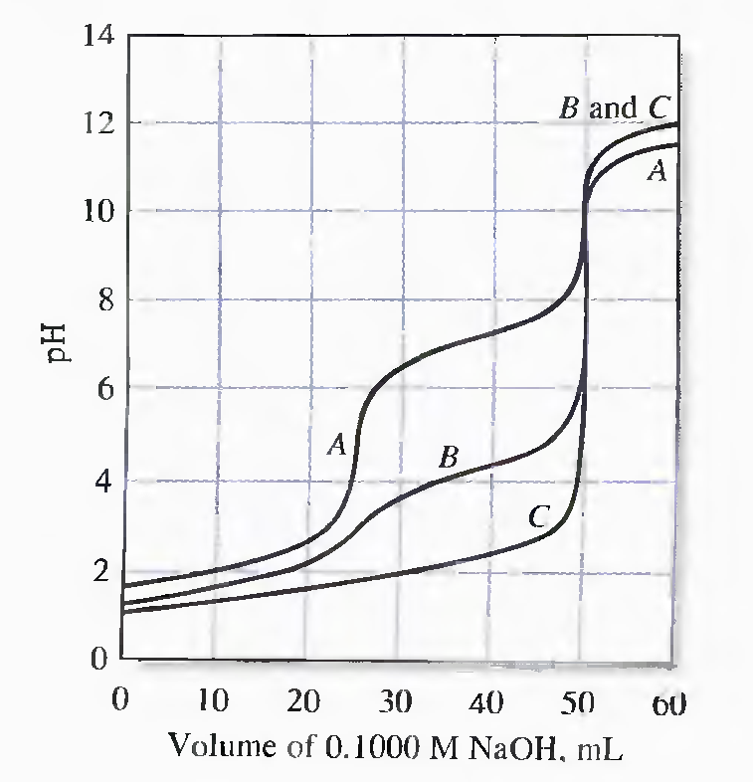
Curves for the titration of polyprotic acids with 0.1000 M NaOH. (A) 25.00 mL of 0.1000 M H₃PO₄, (B) 0.1000 M oxalic acid, and (C) 0.1000 M H₂SO₄.

Curve A is for the triprotic phosphoric acid. Here, the ratio K_{al}/K_{a2} is approximately 10⁵ , as is K_{a2}/K_{a3}. This results in two well-defined end points, either of which is satisfactory for analytical purposes. An acid range indicator will provide a color change when 1 mol of base has been introduced for each mole of acid; a base range indicator will require 2 mol of base per mole of acid. The third hydrogen of phosphoric acid is so slightly dissociated (K_{a3} = 4.5 X 10⁻¹³) that no practical end point is associated with its neutralization. The buffering effect of the third dissociation is noticeable, however, and causes the pH for curve A to be lower than the pH for the other two curves in the region beyond the second equivalence point.

Curve C is for sulfuric acid, a substance that has one fully dissociated proton and one that is dissociated to a relatively large extent (K_{a2} = 1.02 X 10⁻²). Because of the similarity in strengths of the two acids, only a single end point, corresponding to the titration of both protons, is observed.

In general, the titration of acids or bases that have two reactive groups yields individual end points that are of practical value only when the ratio between the two dissociation constants is at least 10⁴. If the ratio is much smaller than this, the pH change at the first equivalence point will prove less satisfactory for an analysis.

Titration Curves for Polyfunctional Bases
A titration curve for a polyfunctional base involves no new principles. Consider the titration of a sodium carbonate solution with standard hydrochloric acid.

CO₃²⁻ + H₂O ↔ OH⁻ + HCO₃⁻, K_{b1} = K_{w}/K_{a2} = 2.13 X 10⁻⁴

HCO₃⁻ + H₂O ↔ OH⁻ + CO_{2(aq)}, K_{b2} = K_{w}/K_{a1} = 2.4 X 10⁻⁸

The initial pH of the solution can be computed from K_{b1}. With the first additions of acid, a carbonate/hydrogen carbonate buffer is formed. In this region, the pH can be calculated from either the hydroxide ion concentration calculated from K_{b1} or the hydronium ion concentration calculated from K_{a2}. Sodium hydrogen carbonate is the principal solute species at the first equivalence point, and acid salt equation is used to compute the hydronium ion concentration. With the addition of more acid, a new buffer consisting of sodium hydrogen carbonate and carbonic acid is formed. The pH of this buffer is obtained from either K_{b2} or K_{a1}.

At the second equivalence point, the solution consists of the weak acid carbon dioxide. The pH can be calculated from K_{a1}. After excess hydrochloric acid has been introduced, the hydronium ion concentration is computed from the concentration of the excess strong acid.

The next figure shows that two end points are observed in the titration of sodium carbonate, the second being appreciably sharper than the first.
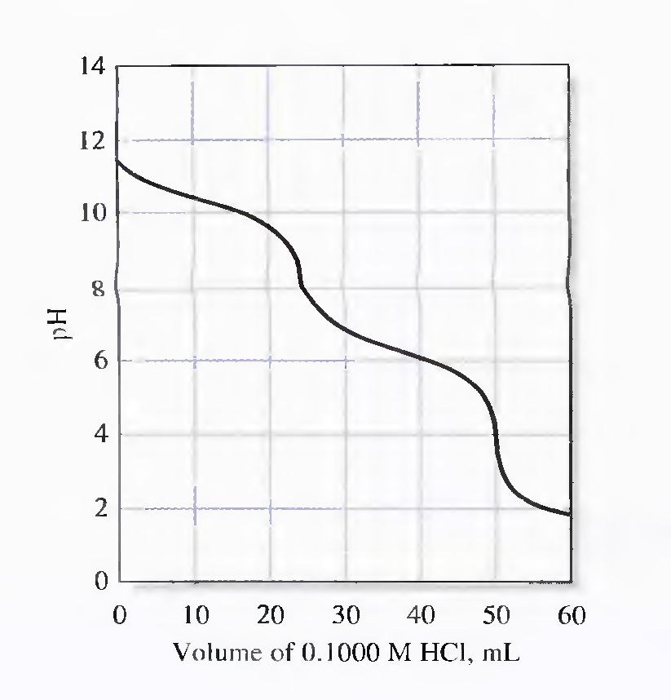
Curve for the titration of 25.00 mL of 0.1 000 M Na₂CO₃ with 0.1000 M

