Example 6
Construct a curve for the titration of 25.00 mL of 0.1000 M maleic acid,(H₂M) HOOC-CHCH-COOH, with 0.1000 M NaOH.

The dissociation equilibria are:

H₂M + H₂O ↔ H₃O⁺ + HM⁻, K_{a1} = 1.3 X 10⁻²
HM⁻ + H₂O ↔ H₃O⁺ + M²⁻ , K_{a2} = 5.9 X 10⁻⁷

Initial pH
We use the first dissociation constant, K_{a1} to calculate [H₃O⁺];
H₂M + H₂O ↔ H₃0⁺ + HM⁻, K_{a1} = 1.3 X 10⁻²
0.1 – x x x

K_{a1} = [H₃O⁺][HM⁻]/[H₂M], ( Note that K_{a1} is large)

1.3 X 10⁻² = x²/(0.1 – x)

X² + 1.3 X 10⁻² x - 1.3 X 10⁻³ = 0
Solving the quadratic equation we obtain;
x = [H₃O⁺] = 3.01 X 10⁻² M
pH = - log (3.01 X 10⁻²) = 1.52

First Buffer Region (e.g.,5 .00 mL of base)
A buffer consisting of the weak acid H₂M and its conjugate base HM⁻ is formed.

[HM⁻] = (5.00 X 0.1000)/30.00 = 1.67 X 10⁻² M

[H₂M] = (25.00 X 0.1000 - 5.00 X 0.1000)/30.00 = 6.67 X 10⁻² M

H₂M + H₂O ↔ H₃O⁺ + HM⁻
(6.67 X 10⁻² – x) x x

HM⁻ + H₂O ↔ HM⁻ + OH⁻
(1.67 X 10⁻² – y) y y

Because K_{a1} is large, x ([H₃O⁺]) can't be neglected, however, since the solution is acidic, y ([OH⁻]) is very small

[H₂M] = 6.67 X 10⁻² – x + y ≈ 6.67 X 10⁻² – x
[HM⁻] = 1.67 X 10⁻² – y + x ≈ 1.67 X 10⁻² + x

K_{a1} = [H₃O⁺][HM⁻]/[H₂M]

1.3 X 10⁻² = x(1.67 X 10⁻² + x)/( 6.67 X 10⁻² – x)

x² - (2.97 X 10⁻²) x - 8.67 X 10⁻⁴ = 0
x = [H₃O⁺] = 1.81 X 10⁻² M
pH = - log (1.81 X 10⁻²) = 1.74

First Equivalence Point (25.00 mLof base)
At the first equivalence point, we have an acid salt solution, HM⁻

[HM⁻] = (25.00 X 0.1000)/50.00 = 5.00 X 10⁻² M

The numerator can be simplified, but the denominator can not. So

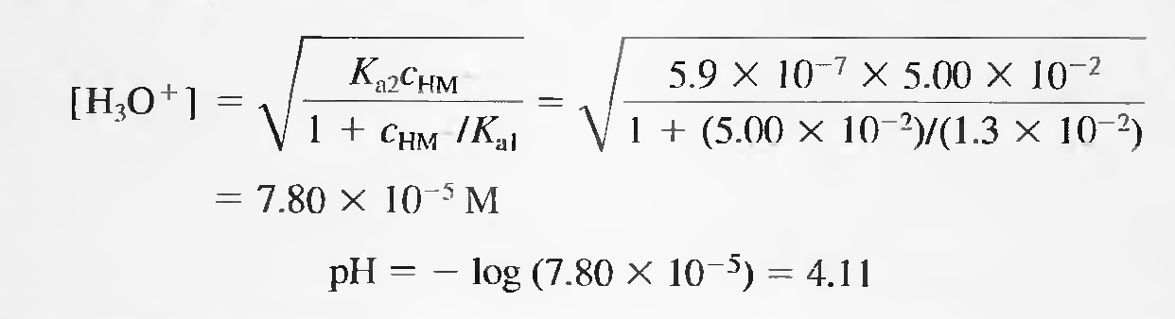

Second Buffer Region(e.g.,25.50 mL of base)
A new buffer system consisting of HM⁻ and M²⁻ is formed. The pH of the mixture is readily obtained from K_{a2}.
[M²⁻] = (25.50 - 25.00)(0.1000)/50.50 = 0.050/50.50 M

[HM⁻] = (25.00 X 0.1000) - (25.50 - 25.00)(0.1000)/50.50 = 2.45/50.50 M

K_{a2} = [H₃O⁺][M²⁻]/[HM⁻]

5.9 X 10⁻⁷ = [H₃O⁺](0.050/50.50)/(2.45/50.50)

[H₃O⁺] = 2.89 X 10⁻⁵ M
pH = 4.54

Second Equivalence Point (50.00 mL of base)
Here, the reaction of the base M²⁻ with water is the predominant equilibrium in the system.
[M²⁻] = (50.00 – 25.00)(0.1000)/75.00 = 0.0333 M

M²⁻ + H₂O ↔ OH⁻ + HM⁻, K_{b1} = K_{w}/K_{a2} = 1.69 X 10⁻⁸
(0.0333 – x) x x

K_{b1} = x²/0.0333 = 1.69 X 10⁻⁸

[OH-] = x = 2.38 X 10⁻⁵ M

pOH = - log(2.38 X 10⁻⁵) = 4.62
pH = 14.00 - 4.62 = 9.38

Beyond the Second Equivalence Point (e.g., 51.00 mL of base)
The pH is calculated from the concentration of excess NaOH. Thus, when 51.00 mL of NaOH are added, we have 1.00 mL excess of 0.1000 M NaOH.
[OH⁻] = (1.00 X 0.1000)/76.00 = 1.32 X 10⁻³ M
pOH = - log (1.32 x 10⁻³) = 2.88
pH = 14.00 - pOH = 11.12

The titration curve for 0.1000 M maleic acid is shown below. Two end points are apparent, either of which could be used as a measure of the concentration of the acid. The second end point is clearly more satisfactory, however, as the pH change is more pronounced.
