Example 3
Calculate the hydronium ion concentration of a 1.00 X 10⁻³ M Na₂HPO₄ solution.

K_{a2} and K_{a3} are used since they both contain [HPO₄²⁻]. Their values are 6.32 X 10⁻⁸ and 4.5 X 10⁻¹³ respectively. Note that (1.00 X 10⁻³ )/(6.32 X 10⁻⁸ ) is much larger than 1. However, K_{a2}[HA⁻] is not much greater than K_{w}. Therefore we use a partially simplified version of equation:

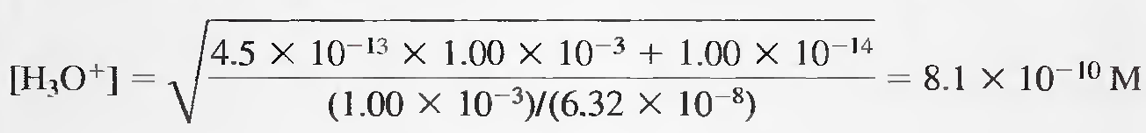

Example 4
Find the hydronium ion concentration of a 0.0100 M NaH₂PO₄ solution.
Here, K_{a1} = 7.11 X 10⁻³ and K_{a2} = 6.32 X 10⁻⁸ are used (both cotain H₂PO₄⁻). The denominator cannot be simplified, but the numerator reduces to K_{a2}[HA⁻]. Thus, the equation becomes:

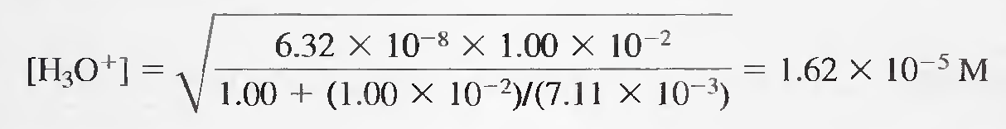

Example 5
Calculate the hydronium ion concentration of a 0.100 M NaHCO₃ solution.

The quilibria that describe the system are:

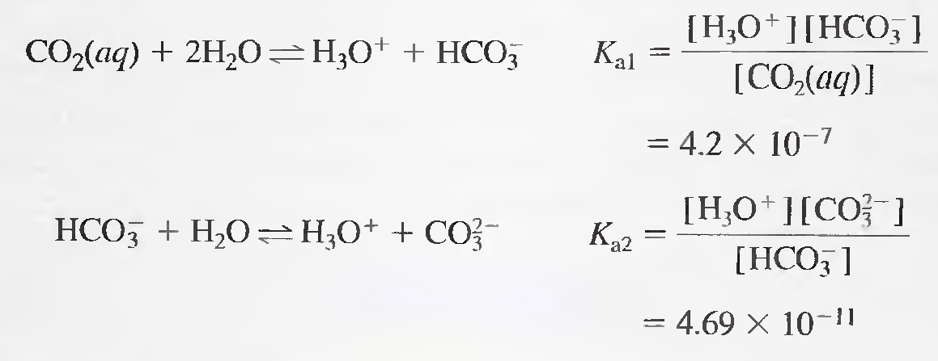
[HA⁻]/K_{al} is much larger than unity; in addition, K_{a2} [HA⁻] has a value of 4.69 X 10⁻¹², which is much greater than K_{w}. Therefore;

[H₃O⁺] = (4.2 X 10⁻⁷ X 4.69 X 10⁻¹¹)^{1/2} = 4.4 X 10⁻⁹ M

Titration Curves for Polyfunctional Acids:
Accurate theoretical titration curves for polyprotic acids can be obtained if the ratio K_{a1}/K_{a2} is somewhat greater than 10³. The next figure shows the titration curve for a diprotic acid, H₂A with K_{al} = 1.00 X 10⁻³ and K_{a2} = 1.00 X 10⁻⁷. For initial pH (point A), we treat the system as if it contained a single monoprotic acid and calculate the pH from K_{al}. In region B, we have a buffer solution consisting of the weak acid H₂A and its conjugate base NaHA. At the first equivalence point (point C), we have a solution of an acid salt, and we use the equation of acid salt to compute pH. In region D, we have a second buffer (HA⁻ and Na₂A), and we calculate the pH using K_{a2}. At point E, the solution contains the conjugate base of a weak acid, (A²⁻). Finally, in region F, we compute the hydroxide concentration from excess NaOH.
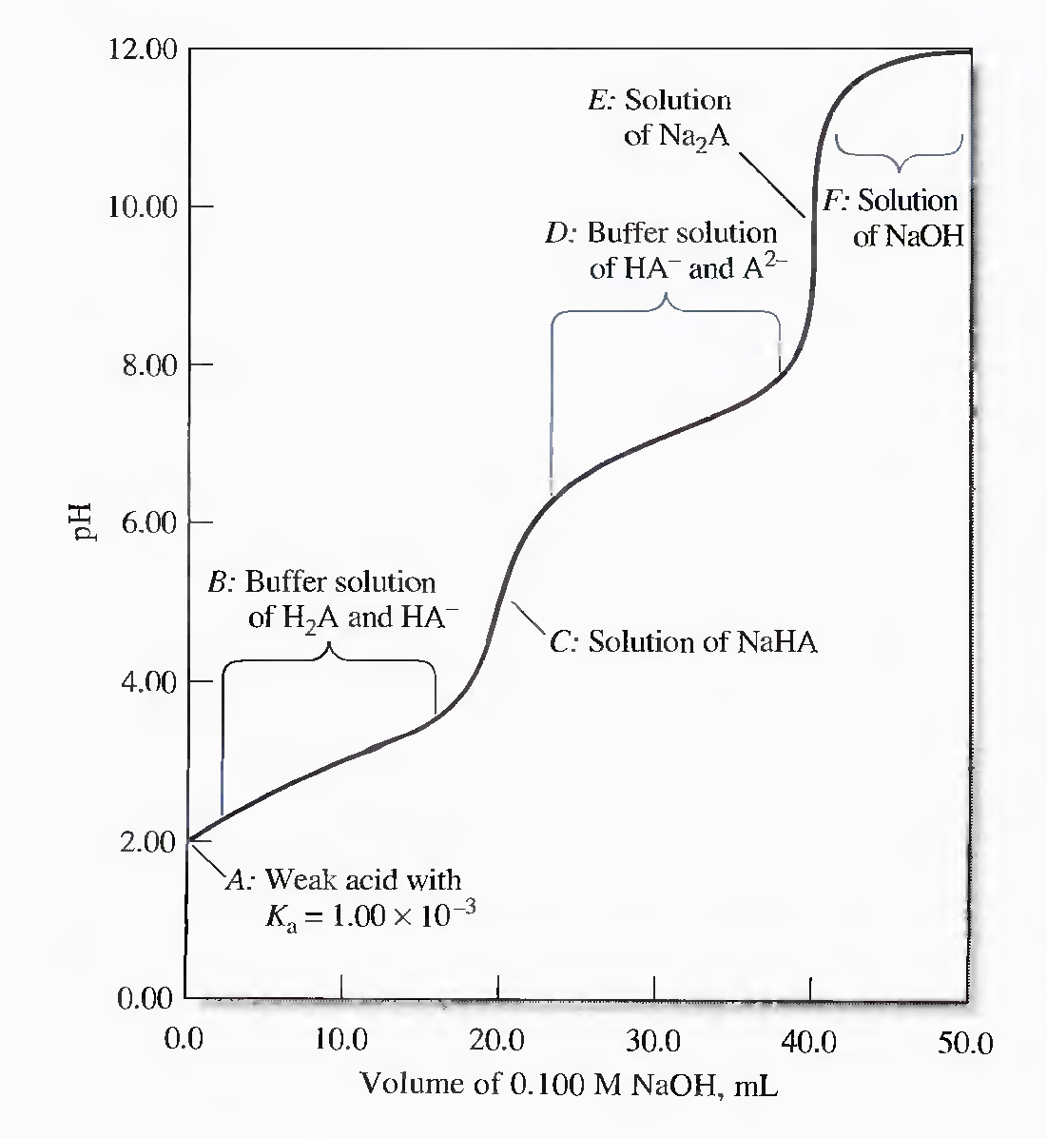
Titration of 20.00 mL of 0.1000 M H₂A with 0.1000 M NaOH.
Example 6
Construct a curve for the titration of 25.00 mL of 0.1000 M maleic acid,(H₂M) HOOC-CHCH-COOH, with 0.1000 M NaOH.

The dissociation equilibria are:

H₂M + H₂O ↔ H₃O⁺ + HM⁻, K_{a1} = 1.3 X 10⁻²
HM⁻ + H₂O ↔ H₃O⁺ + M²⁻ , K_{a2} = 5.9 X 10⁻⁷

Initial pH
We use the first dissociation constant, K_{a1} to calculate [H₃O⁺];
H₂M + H₂O ↔ H₃0⁺ + HM⁻, K_{a1} = 1.3 X 10⁻²
0.1 – x x x

K_{a1} = [H₃O⁺][HM⁻]/[H₂M], ( Note that K_{a1} is large)

1.3 X 10⁻² = x²/(0.1 – x)

X² + 1.3 X 10⁻² x - 1.3 X 10⁻³ = 0
Solving the quadratic equation we obtain;
x = [H₃O⁺] = 3.01 X 10⁻² M
pH = - log (3.01 X 10⁻²) = 1.52

First Buffer Region (e.g.,5 .00 mL of base)
A buffer consisting of the weak acid H₂M and its conjugate base HM⁻ is formed.

[HM⁻] = (5.00 X 0.1000)/30.00 = 1.67 X 10⁻² M

[H₂M] = (25.00 X 0.1000 - 5.00 X 0.1000)/30.00 = 6.67 X 10⁻² M

H₂M + H₂O ↔ H₃O⁺ + HM⁻
(6.67 X 10⁻² – x) x x

HM⁻ + H₂O ↔ HM⁻ + OH⁻
(1.67 X 10⁻² – y) y y

Because K_{a1} is large, x ([H₃O⁺]) can't be neglected, however, since the solution is acidic, y ([OH⁻]) is very small

[H₂M] = 6.67 X 10⁻² – x + y ≈ 6.67 X 10⁻² – x
[HM⁻] = 1.67 X 10⁻² – y + x ≈ 1.67 X 10⁻² + x

K_{a1} = [H₃O⁺][HM⁻]/[H₂M]

1.3 X 10⁻² = x(1.67 X 10⁻² + x)/( 6.67 X 10⁻² – x)

x² - (2.97 X 10⁻²) x - 8.67 X 10⁻⁴ = 0
x = [H₃O⁺] = 1.81 X 10⁻² M
pH = - log (1.81 X 10⁻²) = 1.74

First Equivalence Point (25.00 mLof base)
At the first equivalence point, we have an acid salt solution, HM⁻

[HM⁻] = (25.00 X 0.1000)/50.00 = 5.00 X 10⁻² M

The numerator can be simplified, but the denominator can not. So

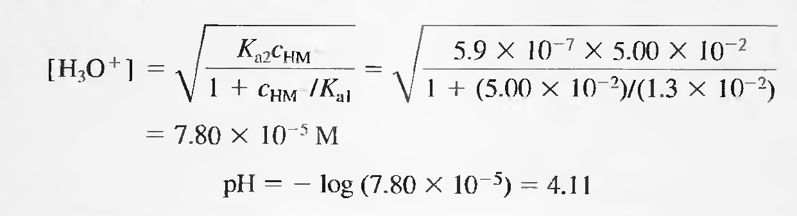

Second Buffer Region(e.g.,25.50 mL of base)
A new buffer system consisting of HM⁻ and M²⁻ is formed. The pH of the mixture is readily obtained from K_{a2}.
[M²⁻] = (25.50 - 25.00)(0.1000)/50.50 = 0.050/50.50 M

[HM⁻] = (25.00 X 0.1000) - (25.50 - 25.00)(0.1000)/50.50 = 2.45/50.50 M

K_{a2} = [H₃O⁺][M²⁻]/[HM⁻]
5.9 X 10⁻⁷ = [H₃O⁺](0.050/50.50)/(2.45/50.50)
[H₃O⁺] = 2.89 X 10⁻⁵ M
pH = 4.54

Second Equivalence Point (50.00 mL of base)
Here, the reaction of the base M²⁻ with water is the predominant equilibrium in the system.
[M²⁻] = (50.00 – 25.00)(0.1000)/75.00 = 0.0333 M

M²⁻ + H₂O ↔ OH⁻ + HM⁻, K_{b1} = K_{w}/K_{a2} = 1.69 X 10⁻⁸
(0.0333 – x) x x
K_{b1} = x²/0.0333 = 1.69 X 10⁻⁸

[OH-] = x = 2.38 X 10⁻⁵ M

pOH = - log(2.38 X 10⁻⁵) = 4.62
pH = 14.00 - 4.62 = 9.38

Beyond the Second Equivalence Point (e.g., 51.00 mL of base)
The pH is calculated from the concentration of excess NaOH. Thus, when 51.00 mL of NaOH are added, we have 1.00 mL excess of 0.1000 M NaOH.
[OH⁻] = (1.00 X 0.1000)/76.00 = 1.32 X 10⁻³ M
pOH = - log (1.32 x 10⁻³) = 2.88
pH = 14.00 - pOH = 11.12

The titration curve for 0.1000 M maleic acid is shown below. Two end points are apparent, either of which could be used as a measure of the concentration of the acid. The second end point is clearly more satisfactory, however, as the pH change is more pronounced.
