Variables That Influence the Behavior of Indicators
The indicator pH range is influenced by several factors such as, temperature, ionic strength, and presence of organic solvents and colloidal particles. The last two factors can cause the transition range to shift by one or more pH units.

Some Common Acid/Base Indicators
Acid/base indicators include a number of organic compounds. Indicators are available for almost any desired pH range. A few common indicators and their properties are listed in the next table.

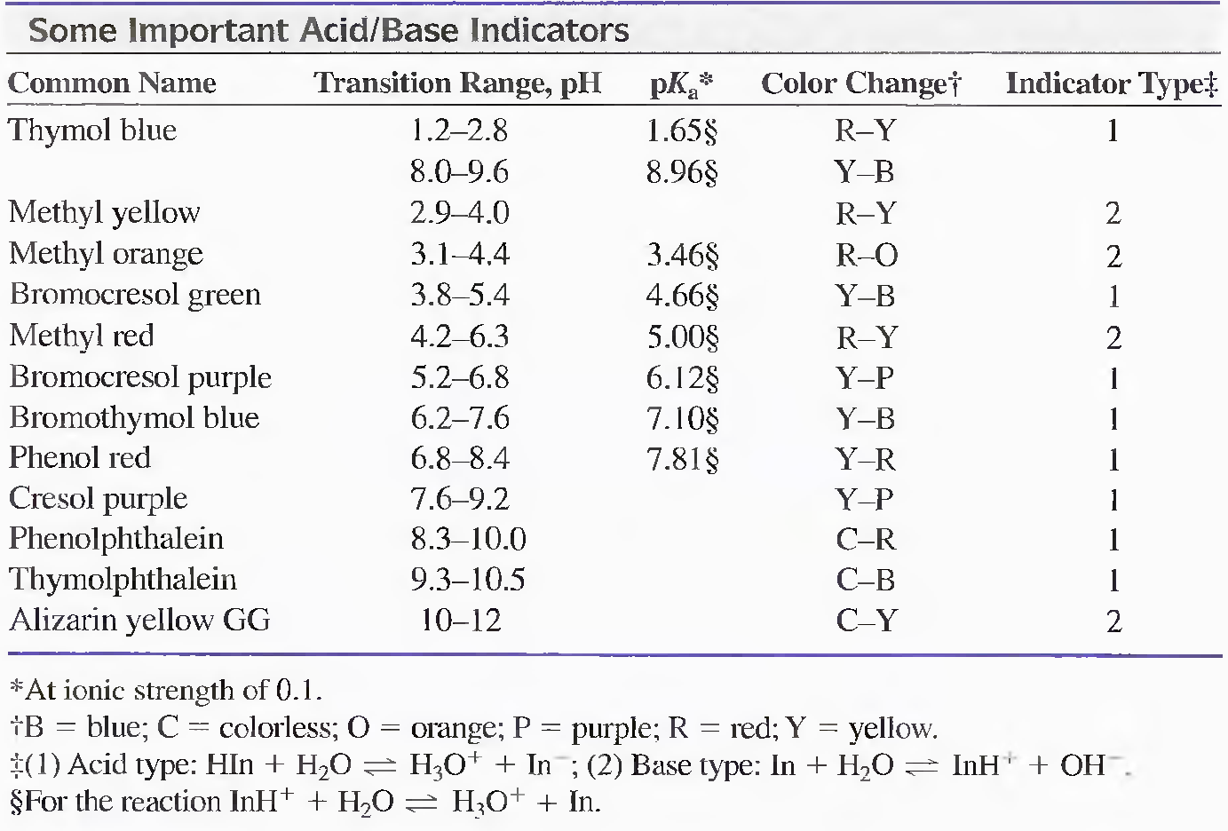

7.3 Titration of Strong Acids and Strong Bases
For solutions of a strong acid that are more concentrated than about 1 X 10⁻⁶ M, we can assume that the equilibrium concentration of H₃O⁺ is equal to the analytical concentration of the acid. The same is true for [OH⁻] in solutions of strong bases.

Titrating a Strong Acid with a Strong Base
Three types of calculations must be done to construct a hypothetical curve for titrating a solution of a strong acid with a strong base.
(1) Pre-equivalence: pH is calculated from the molar concentration of unreacted acid.
(2) Equivalence: the hydronium ion concentration is derived directly from K_{w} for water.
[H⁺] = [OH⁻] = 1 X 10⁻⁷ M & pH = pOH = 7

(3) Post-equivalence: the analytical concentration of the excess base is computed, and then the hydronium ion concentration calculated using K_{w}.

K_{w} = [H₃O⁺][OH⁻] = 1 X 10⁻¹⁴

pK_{w} = pH + pOH = 14.00

Example 1
Generate the hypothetical titration curve for the titration of 50.00 mL of 0.0500 M HCI with 0.1000 M NaOH.

Initial Point:
[H₃O⁺] = [HCl] = 0.0500 M

pH = -log[H₃O⁺] = -log 0.0500 = 1.30

After Addition of 10.00 mL of NaOH:
[H₃O⁺] decreases as a result of both reaction with the base and dilution.
[H₃O⁺] = [HCl] (left) = (initial HCl – added NaOH)/total volume
= (0.0500 X 50.00 – 0.1000 X 10)/(50.00 + 10)
= 2.500 x 10⁻² M

pH = - log [H₃O⁺] = - log 2.500 x 10⁻² = 1.60

After Addition of 25.00 mL of NaOH: The Equivalence Point
[H⁺] = [OH⁻] = 1 X 10⁻⁷ M
pH = 7
After Addition of 25.10 mL of NaOH:
pH is calculated from pOH (excess NaOH)
[OH⁻] = excess NaOH = (added NaOH – initial HCl)/total volume
= (0.1000 X 25.10 – 0.0500 X 50.00)/75.1
= 1.33 X 10⁻⁴ M

pOH = - log 1.33 X 10⁻⁴ = 3.88
pH = 14.00 – 3.88 = 10.12

The Effect of Concentration
The effects of reagent and analyte concentrations on the neutralization titration curves for strong acids are shown in the figure below. The change in pH in the equivalence-point region is larger for more concentrated reagent.

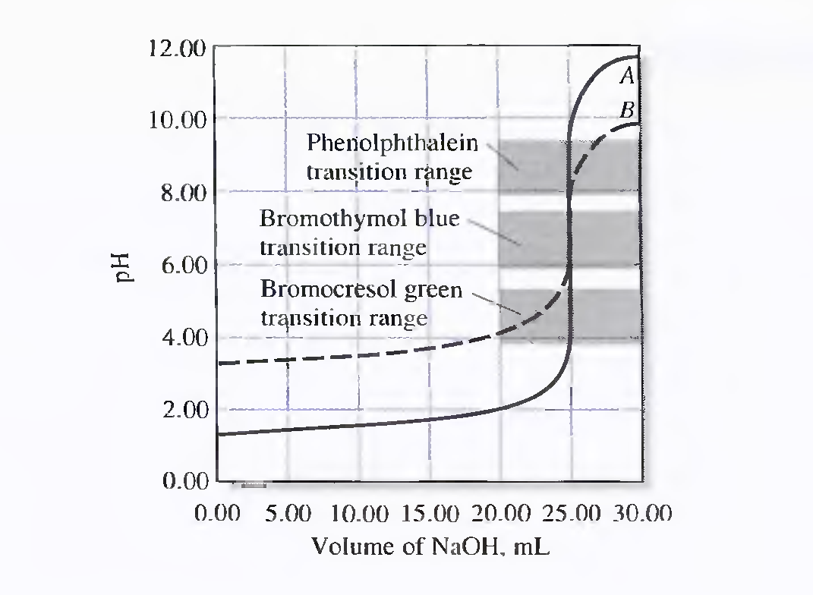
Titration curves for HCI with NaOH. Curve A: 50.00 mL of 0.0500 M HCI with 0.1000 M NaOH. Curve B: 50.00 mL of 0.000500 M HCI with 0.001000 M NaOH.

Choosing an Indicator
The previous figure shows that the selection of an indicator is not critical when the reagent concentration is approximately 0.1M. Here, the volume differences in titrations with the three indicators shown are of the same magnitude as the uncertainties associated with reading the buret; therefore, they are negligible. Bromocresol green is unsuited for a titration involving the 0.001 M reagent because the color change occurs over a 5-mL range well before the equivalence point. The use of phenolphthalein is subject to similar objections. Only bromothymol blue provides a satisfactory end point with a minimal systematic error in the titration of the more dilute solution.

7.4 Titrating a Strong Base with a Strong Acid
Titration curves for strong bases are analogous to those for strong acids. Before the equivalence point, the solution is highly basic, the hydroxide ion concentration is related to the analytical concentration of the unreacted base. At the equivalence point the solution is neutral and becomes acidic in the region beyond the equivalence point. The hydronium ion concentration is then equal to the analytical concentration of the excess strong acid.

Example 2
Calculate the pH during the titration of 50.00 mL of 0.0500 M NaOH with 0.1000 M HCI after the addition of the following volumes of reagent: (a) 24.50 mL, (b) 25.00 mL, (c) 25.50 mL.

(a) At 24.50 mL HCl: (Before equivalence)
[H₃O⁺] is calculated from excess hydroxide using Kw
Excess [OH⁻] = (initial mmol NaOH – added mmol HCl)/total volume
= (50.00 X 0.0500 - 24.50 X 0.100)/74.5
= 6.71 X 10⁻⁴ M

[H₃O⁺] = Kw/[OH⁻] = 1.00 x 10⁻¹⁴/(6.71 X 10⁻⁴ ) = 1.49 X 10⁻¹¹ M
pH = - log(1.49 X 10⁻¹¹) = 10.83

(b) At 25.00 mL HCl: (Equivalence point)
[H₃O⁺] = (Kw)^{1/2} = 1 X 10⁻⁷ M

pH = - log (1 X 10⁻⁷) = 7.00

(c) At 25.50 mL HCl: (After equivalence)
[H₃O⁺] = (added mmol HCl – initial mmol NaOH)/total volume
= (25.50 X 0.100 - 50.00 X 0.0500)/75.5
= 6.62 X 10⁻⁴ M

pH = - log (6.62 X 10⁻⁴ ) = 3.18

Curves for the titration of 0.0500 M and 0.00500 M NaOH with 0.1000 M and 0.0100 M HCI are shown in the next figure. Indicator selection is based on the same considerations described for the titration of a strong acid with a strong base.
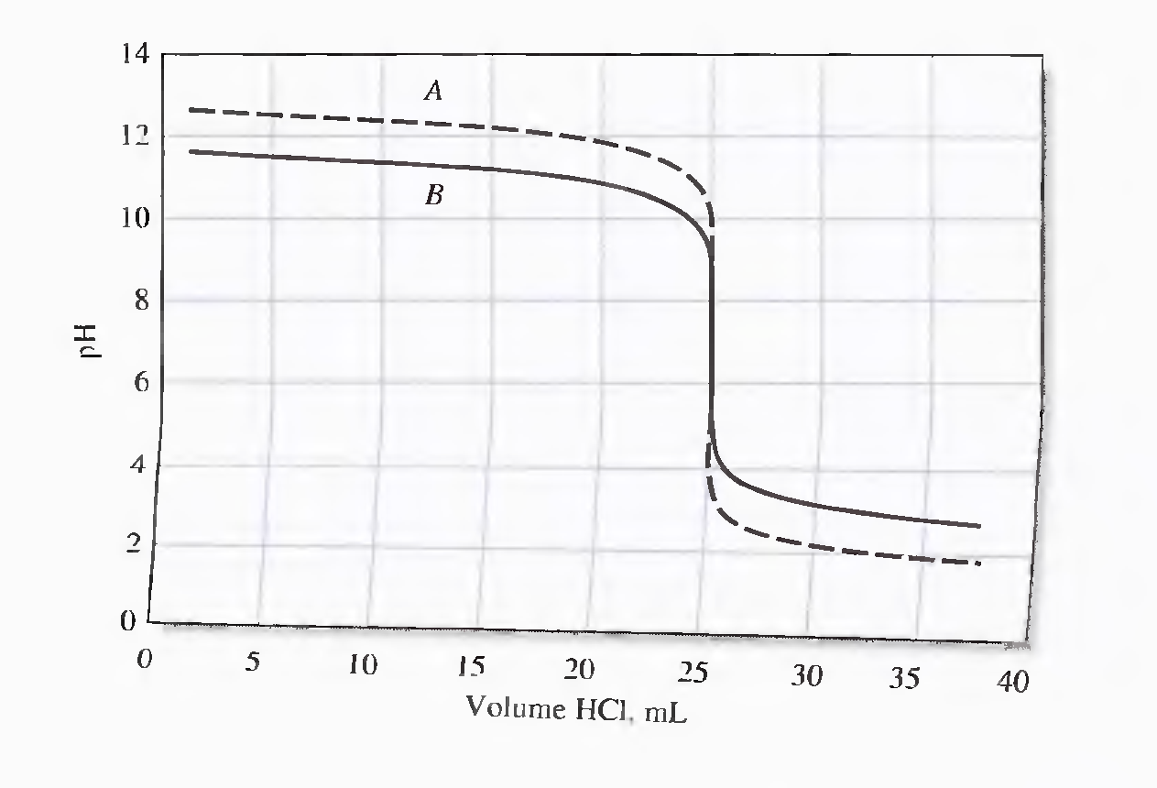

Titration curves for NaOH with HCl. Curve A: 50.00 mL of 0.0500 M NaOH with 0.1000 M HCl. Curve B: 50.00 mL of 0.00500 M NaOH with 0.0100 M HCl.

Titration Curves For Weak Acids
Four types of calculations are needed to derive a titration curve for a weak acid (or a weak base):
1. At the beginning, the solution contains only a weak acid (or a weak base) and pH is calculated from the concentration of that solute and its dissociation constant.
2. Before equivalence, the solution consists of a buffer. The pH of the buffer can be calculated from the analytical concentrations of the conjugate base (or acid) and the residual concentrations of the weak acid (or base).
3. At the equivalence point, the solution contains only the conjugate of the weak acid (or base); that is a salt, and the pH is calculated from the concentration of this product.
4. Beyond the equivalence point, pH is governed largely by the concentration of the excess strong acid (or strong base) titrant.

Example 3
Generate a curve for the titration of 50.00 mL of 0.1000 M acetic acid with 0.1000 M sodium hydroxide.

Initial pH
Calculate the pH of a 0.1000 M solution of HOAc
Ka = [H₃O⁺][OAc⁻]/[HOAc] = x²/[HOAc]

[H₃O⁺] = x = (Ka[HOAc])^{1/2} = (1.75 X 10⁻⁵ X 0.100)^{1/2} = 1.32 X 10⁻³ M

pH = -log (1.32 X 10⁻³) = 2.88

pH after Addition of 5.00 mL of Reagent
A buffer solution consisting of NaOAc and HOAc has been produced.
[HAOc] = (50.00 mL X 0.100 M - 5.00 mL X 0.100 M)/55.00 = 4.500/55 M
[OAc⁻] = (5.00 mL X 0.100 M)/55 = 0.500/55.00 M

Ka = [H₃O⁺] (0.500/55.00)/(4.500/55.00) = 1.75 X 10⁻⁵
[H₃O⁺] = 1.58 X 10⁻⁴ M
pH = 3.80

pH after Addition of 25.00 mL of Reagent;(half-Neutralization)
[HAOc] = (50.00 mL X 0.100 M - 25.00 mL X 0.100 M)/55.00 = 2.500/55.00 M
[OAc⁻] = (25.00 mL X 0.100 M)/55.00 = 2.500/55.00 M
Ka = [H₃O⁺] (2.500/55.00)/(2.500/55.00) = [H₃O⁺] =1.75 X 10⁻⁵
pH = pKa = 4.76

Equivalence Point pH
At the equivalence point, all the acetic acid has been converted to sodium acetate. The solution is therefore similar to one formed by dissolving that salt in water. In the present example, the NaOAc concentration is 0.0500 M.
OAc⁻ + H₂O ↔ HOAc + OH⁻

[OAc-] = 0.0500 - [OH⁻] ≈ 0.0500 M

K_{b} = Kw/Ka = 1X10⁻¹⁴/1.75 X 10⁻⁵ = 5.71 X 10⁻¹⁰

K_{b} = [HAOc][OH⁻]/[OAc⁻] = x²/[OAc⁻] = 5.71 X 10⁻¹⁰

[OH⁻] = x = (0.0500 X 5.71 X 10⁻¹⁰)^{1/2} = 5.34 X 10⁻⁶ M

pH = 14.00 - (-log 5.34 X 10⁻⁶ ) = 8.73

pH after Addition of 50.01 mL of Base
After equivalence, both excess strong base and the acetate ion (weak base) are present. The contribution from the acetate ion is small. However, because the excess of strong base represses the reaction of acetate with water, the contribution from the acetate is even smaller.

[OH⁻] ≈ [NaOH] = (50.01 mL X 0.1000 M - 50.00 mL X 0.1000 M)/100.01mL
= 1.00 X 10⁻⁵ M

pH = 14.00 - [-log (1.00 X 10⁻⁵)] = 9.00

