Adsorption Indicators: The Fajans Method
An adsorption indicator is an organic compound that tends to be adsorbed onto the surface of the solid in a precipitation titration. Ideally, the adsorption (or desorption) occurs near the equivalence point and results not only in a color change but also in a transfer of color from the solution to the solid (or the reverse). Fluorescein (shown below) is a typical adsorption indicator that is useful for the titration of chloride ion with silver nitrate. In aqueous solution, fluorescein partially dissociates into hydronium ions and negatively charged fluoresceinate ions that are yellow-green. The fluoresceinate ion forms an intensely red silver salt. Whenever this dye is used as an indicator, however, its concentration is never large enough to precipitate as silver fluoresceinate.
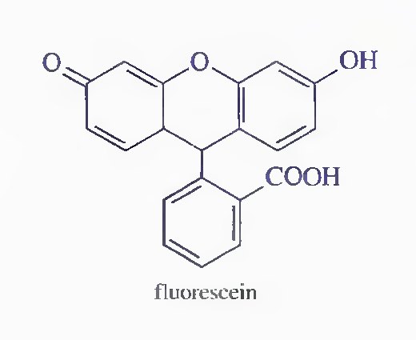
In the early stages of the titration of chloride ion with silver nitrate, the silver chloride particles are negatively charged because of adsorption of excess chloride ions. The dye anions are repelled from this surface by electrostatic repulsion and impart a yellow-green color to the solution. Beyond the equivalence point, the silver chloride particles strongly adsorb silver ions and thereby acquire a positive charge. Fluoresceinate anions are now attracted into the counter-ion layer that surrounds each silver chloride particle. The net result is the appearance of the red color of silver fluoresceinate in the surface layer of the solution surrounding the solid. It is important to emphasize that the color change is an adsorption (not a precipitation) process, because the solubility product of the silver fluoresceinate is never exceeded. The adsorption is reversible, the dye being desorbed on back-titration with chloride ion. Titrations involving adsorption indicators are rapid, accurate, and reliable, but their application is limited to the relatively few precipitation reactions in which a colloidal precipitate is formed rapidly.

Iron(III) Ion; The Volhard Method
In the Volhard method, silver ions are titrated with a standard solution of thiocyanate ion:
Ag⁺ + SCN⁻ → AgSCN_{(s)}
Iron(III) serves as the indicator. The solution turns red with the first slight excess of thiocyanate ion:
Fe³⁺ + SCN⁻ → FeSCN²⁺_{(red)}
The titration must be carried out in acidic solution to prevent precipitation of iron(III) as the hydrated oxide.
Volhard method can be used indirectly for determination of halide ions. A measured excess of standard silver nitrate solution is added to the sample, and the excess silver is determined by back-titration with a standard thiocyanate solution. The strong acidic environment required for the Volhard procedure represents a distinct advantage over other titrimetric methods of halide analysis because such ions as carbonate, oxalate, and arsenate (which form slightly soluble silver salts in neutral media but not in acidic media) do not interfere.
Silver chloride is more soluble than silver thiocyanate. In chloride determinations by the Volhard method, the reaction;
occurs to a significant extent near the end of the back-titration of the excess silver ion. This reaction causes the end point to fade and results in an overconsumption of thiocyanate ion, which in turn leads to low values for the chloride analysis. This error can be avoided by filtering the silver chloride before back-titration. Filtration is not required in the determination of other halides because they all form silver salts that are less soluble than silver thiocyanate.
Applications of Standard Silver Nitrate Solutions
Some typical applications of precipitation titrations with silver nitrate are listed in the following table. In most of these methods, the analyte is precipitated with a measured excess of silver nitrate, and the excess is determined by a Volhard titration with standard potassium thiocyanate.
Both silver nitrate and potassium thiocyanate are obtainable in primary-standard quality. The latter is somewhat hygroscopic, and thiocyanate solutions are ordinarily standardized against silver nitrate. Both silver nitrate and potassium thiocyanate solutions are stable indefinitely.
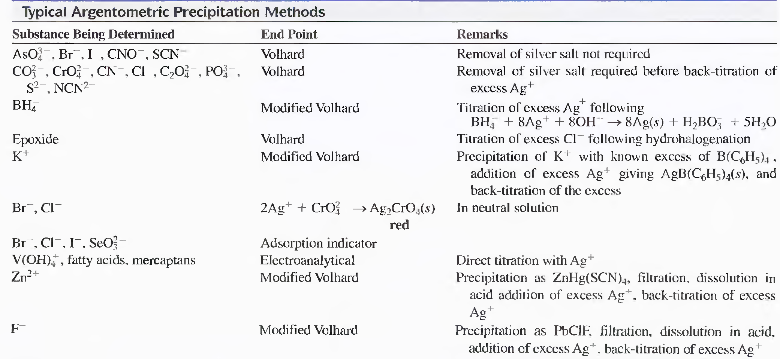

Chapter 7

Principles of Neutralization Titrations

Objectives
The aim of this chapter is to understand the basic principles of neutralization (acid-base) titrations, and to have an idea about the nature and way of action of some common indicators that are used. In addition, titration curves that are plots of pH versus volume of titrant will be explored, and several examples of pH calculations will be presented. Titration curves for strong and weak acids and bases will also be described.

7.1 Standard Solutions
Strong acids or strong bases are used as standard reagents for neutralization titrations, because they react more completely with an analyte than weak reagents do, and therefore provide sharper end points. Most common reagents are HCI, HClO₄, H₂SO₄, NaOH, and KOH. Nitric acid is seldom used because of its oxidizing power.

7.2 Acid/Base Indicators
An acid/base indicator is a weak organic acid or a weak organic base whose undissociated form differs in color from its conjugate base or its conjugate acid form. For example, the behavior of an acid-type indicator, HIn, is described by the equilibrium:
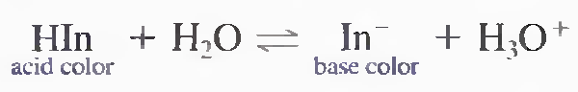

For a base-type indicator, the equilibrium is:
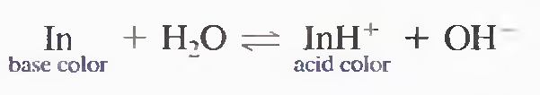

The equilibrium-constant for the dissociation of an acid-type indicator is:
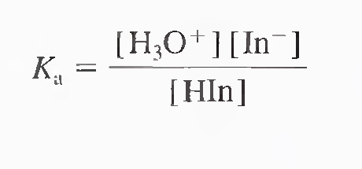
It can be rearranged for the hydronium ion concentration;
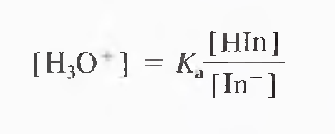
The indicator exhibits its acid color when
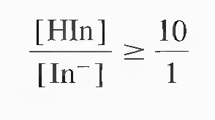
And its base color when
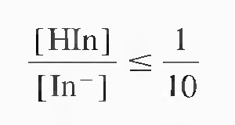
Between these two values, the indicator has an intermediate color.

Substituting the two values in the hydronium ion concentration term, we find that [H₃O⁺] = 10 Ka for the full acid color and [H₃O⁺] = 0.1 Ka for the full base color.

To obtain the indicator pH range, we take the negative logarithms of the two expressions:

pH (acid color) = -log (10K a ) = pKa + 1
pH (basic color) = -log (0.1 Ka) = pKa – 1

indicator pH range = pKa 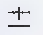 1
An indicator with an acid dissociation constant of 1 X 10⁻⁵ (pKa = 5) typically shows a complete color change when the pH of the solution changes from 4 to 6.

