Precipitation Titrimetry
Precipitation titrimetry, is based on reactions that yield ionic compounds of limited solubility. Because of the slow rate of formation of most precipitates, there are only a few precipitating agents that can be used in titrimetry. The most widely used precipitating reagent is silver nitrate, which is used for the determination of halides, halide-like anions (SCN⁻, CN⁻, CNO⁻), mercaptans., fatty acids, and several divalent and trivalent inorganic anions. Titrimetric methods based on silver nitrate are called argentometric methods. (derived from the Latin name of silver; argentum).

Precipitation Titration Curves Involving Silver Ion
A titration curve for an argentometric method usually consists of a plot of pAg versus the volume of silver nitrate added. To construct titration curves, three type of calculations are required, each of which corresponds to a distinct stage in the reaction: (1) pre-equivalence, (2) equivalence. and (3) post-equivalence.

Example 10
Perform calculations needed to generate a titration curve for 50.00 mL of 0.0500 M NaCI with 0.1000 M AgNO₃ (for AgCl, Ksp = 1.82 X 10⁻¹⁰ ).
Ag⁺_{(aq)} + Cl⁻_{(aq)} → AgCl_{(s)}

(1) Pre-equivalence-Point: (e.g., 10.00 mL AgNO₃)
Here, [Ag⁺] is computed from unreacted chloride using Ksp for AgCl_{(s)}

[Cl⁻] = (initial mmol NaCl – added mmol AgNO₃)/total volume
= (0.0500 X 50.00 – 0.1000 X 10.00)/60.00
= 0.02500 M

Ksp = [Ag⁺][Cl⁻]
[Ag⁺] = Ksp/[Cl⁻] = 1.82 X 10⁻¹⁰/ 0.02500
= 7.28 X 10⁻⁹ M

pAg = - log (7.28 X 10⁻⁹) = 8.14

(2) Equivalence Point: (25.00 mL AgNO₃)
[Ag⁺] = [Cl⁻] = (Ksp)^{1/2}
[Ag⁺] = 1.349 X 10⁻⁵ M
pAg = -log (1.349 X 10⁻⁵) = 4.87

(3) Post-equivalence-Point: (26.00 mL AgNO₃)
Excess [Ag⁺] is calculated from the formula:

[Ag⁺] = (added mmol AgNO₃ – initial mmol NaCl)/total volume
= (0.1000 X 26.00 – 0.0500 X 50.00)/76
= 1.316 X 10⁻³ M

pAg = - log (1.316 X 10⁻³) = 2.88
Additional data are obtained in the same way and are shown in the following table:

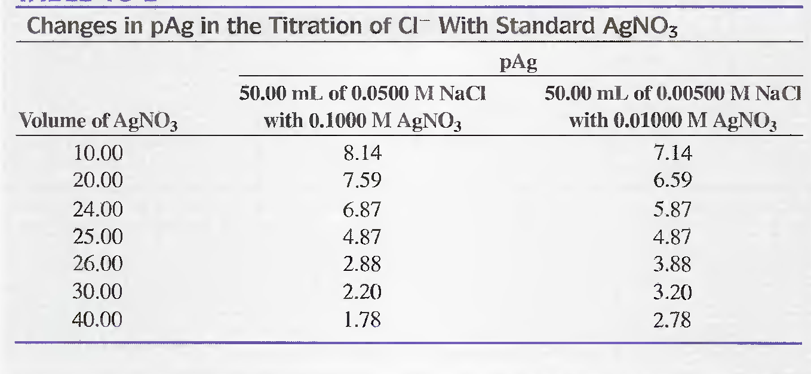
The Effect of Concentration on Titration Curves
The effect of reagent and analyte concentrations on titration curves is shown by the two sets of data in the above table. The two titration curves are shown in the next figure:
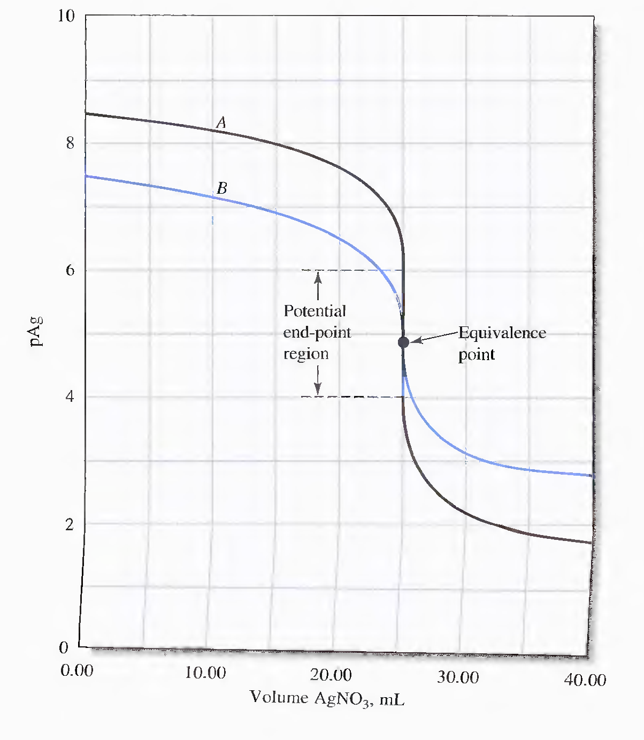
With 0.1 M AgNO₃ (Curve A), the change in pAg in the equivalence-point region is large. With the 0.01 M reagent, the change is markedly less but still pronounced. Thus, an indicator for Ag⁺ that produces a signal in the 4.0 to 6.0 pAg range should give a minimum error for the stronger solution. For the more dilute chloride solution, the change in pAg in the equivalence-point region would be too small to be detected precisely with a visual indicator.

The Effect of Reaction Completeness on Titration Curves
The change in pAg at the equivalence point increases as the reaction becomes more complete (as solubility products decrease). Ions forming precipitates with solubility products much larger than about 10⁻¹⁰ do not yield satisfactory end points.

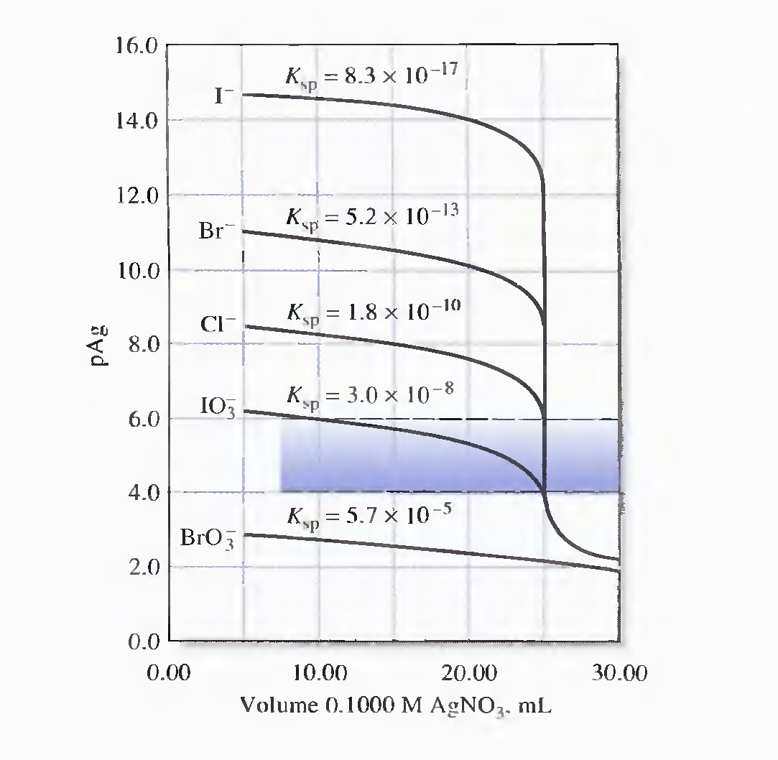

Indicators for Argentometric Titrations
Three types of end points:
(1) chemical, (2) potentiometric, and (3) amperometric.
Potentiometric end points are obtained by measuring the potential between a silver electrode and a reference electrode. In amperometric end points, the current generated between a pair of silver microelectrodes in the solution of the analyte is measured and plotted as a function of reagent volume.
The end point produced by a chemical indicator usually consists of a color change or, the appearance or disappearance of turbidity in the solution being titrated. The requirements for an indicator for a precipitation titration are:
1. the color change should occur over a limited range in p-function of the reagent or the analyte
2. the color change should take place within the steep portion of the titration curve for the analyte.
Three chemical indicators will be described:

Chromate Ion; The Mohr Method
Sodium chromate can serve as an indicator for the argentometric determination of chloride, bromide, and cyanide ions by reacting with silver ion to form a brick-red silver chromate (Ag₂CrO₄) precipitate in the equivalence-point region.
The silver ion concentration at chemical equivalence in the titration of chloride with silver ions is given by:
[Ag⁺] = (Ksp)^{1/2} = 1.35 X 10⁻⁵ M

The chromate ion concentration required to initiate formation of silver chromate under this condition can be computed from Ksp for silver chromate,
Ksp = [Ag⁺]²[CrO₄²⁻]
[CrO₄²⁻] = 1.2 X 10⁻¹²/(1.35 X 10⁻⁵)² = 6.6 X 10⁻⁶ M

A chromate ion concentration of 6.6 X 10⁻³ M gives an intense yellow color that formation of the red silver chromate is not readily detected, and lower concentrations of chromate ion should be used. Thus, excess silver nitrate is required before precipitation begins. An additional excess of the reagent must also be added to produce enough silver chromate to be seen. These two factors create a positive systematic error that becomes significant at reagent concentrations lower than about 0.1 M. A correction for this error can readily be made by blank titration of a chloride-free suspension of calcium carbonate. Alternatively, the silver nitrate solution can be standardized against primary-standard-grade sodium chloride using the same conditions as in the analysis. This technique compensates not only for the overconsumption of reagent but also for the acuity of the analyst in detecting the appearance of the color.
The Mohr titration must be carried out at a pH of 7 to 10 because chromate ion is the conjugate base of the weak chromic acid. In acidic solutions, the chromate ion concentration is too low to produce the precipitate near the equivalence point. Normally, a suitable pH is achieved by saturating the analyte solution with sodium hydrogen carbonate.

